Partial / residual correlation: USDCAD and EURGBP
Method 07 / daily log returns / leave-currency-out USD factor / Alpari D1 full available history

Study setup
Logical pair: USDCAD , EURGBP
Broker symbols: USDCAD_i , EURGBP_i
Snapshot: 2026-11-03_majors_alpari_D1
Timeframe: D1
Matched return window: 1999-01-06 to 2026-11-02 (UTC bar dates)
Matched return count n: 7129
Dropped unfinished last bar dated 2026-11-03 UTC after a tick-volume check against the prior complete day.
USD-strength sign rule: minus log return when USD is the quote (EURUSD, GBPUSD, AUDUSD, NZDUSD); plus log return when USD is the base (USDJPY, USDCHF, USDCAD). EURGBP is never a constituent.
Control z constituents (4): AUDUSD, NZDUSD, USDJPY, USDCHF
z_t = equal-weight mean of those USD-strength returns on the same day
Complete matched rows (Excel): USDCAD-EURGBP_Partial_D1.xlsx
Complete matched rows (HTML table): USDCAD-EURGBP_Partial_D1_data.html

Method carried forward
Partial / residual correlation regresses each matched daily log return of close, ln(close_t / close_t-1), on the same leave-currency-out USD strength factor z, then takes Pearson correlation of the two residual series. Quotes are not inverted. z is the equal-weight mean of USD-strength returns from other majors that do not share a non-USD currency with either leg; EURGBP is never a constituent. USD-strength is minus the log return when USD is the quote (EURUSD, GBPUSD, AUDUSD, NZDUSD) and plus the log return when USD is the base (USDJPY, USDCHF, USDCAD). OLS uses an intercept on each leg. rho_partial is symmetric under swap of the two symbols. It describes leftover linear co-movement after removing linear z; it is not a cause, not a lead, and not a trading signal. Daily rows are not independent and residuals are estimated, so the two-sided p-value and Fisher interval are secondary. Same-sample raw Pearson r is a side check only.

Regression on z
leg | intercept_a_or_c | slope_b_or_d | R2
USDCAD | 2.33e-06 | 0.5620356 | 0.31627975
EURGBP | 2.114e-05 | -0.16061731 | 0.02882637

Results
rho_partial: 0.099152
Two-sided p-value: 4.82302e-17
Approximate 95% Fisher interval: [0.076113, 0.122085]
Same-sample raw Pearson r: -0.014688
rho_partial minus r: 0.113840

Conclusion
Over 7129 matched daily rows for USDCAD and EURGBP after removing a leave-currency-out USD factor built from 4 constituents, rho_partial is 0.0992 (positive, weak residual linear link in this sample). Approximate 95% Fisher interval: [0.0761, 0.1221]. Same-sample raw Pearson r is -0.0147 (partial minus r = 0.1138). Leg R-squared on z: USDCAD=0.3163, EURGBP=0.0288. Two-sided p under the usual independent-pairs model is 4.823e-17; residuals are estimated and daily FX rows are linked, so treat p as secondary. This does not establish cause, lead-lag, or a lasting trading rule.

Charts
Daily closes
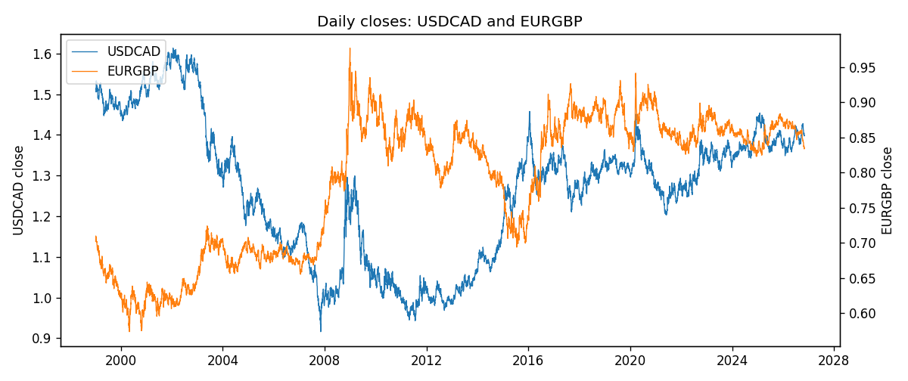
Log returns and control z
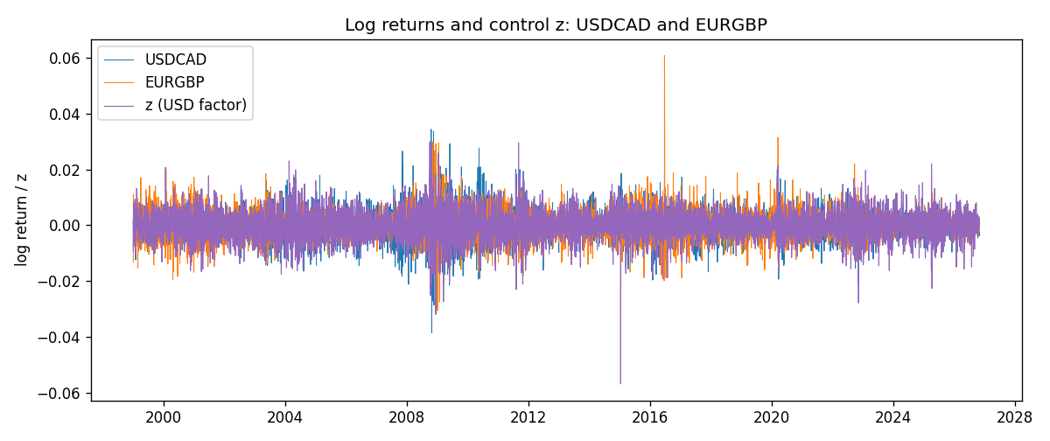
Residual scatter e_x vs e_y
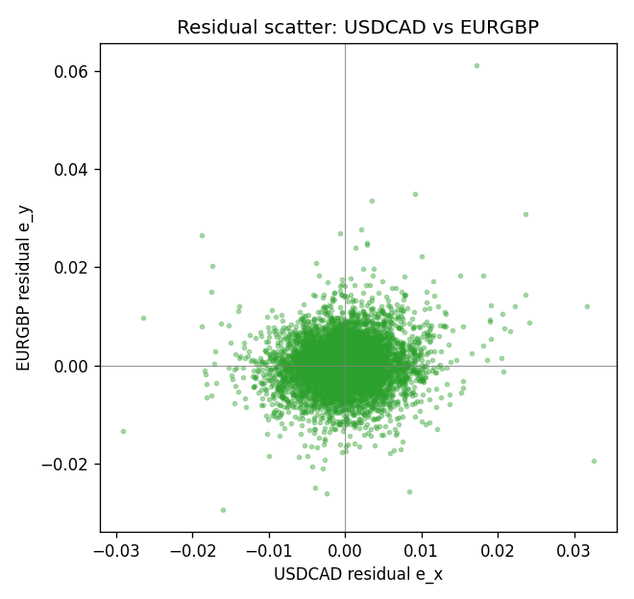

Data report
Every matched row that entered the partial correlation is stored in the sibling Excel workbook named USDCAD-EURGBP_Partial_D1.xlsx. That file is the complete data archive for redrawing charts. Embedding all rows as a Word table is impractical at this length; the Word file holds the column list, column summaries, and the first and last 15 matched rows.
Columns: time, USDCAD_open, EURGBP_open, USDCAD_high, EURGBP_high, USDCAD_low, EURGBP_low, USDCAD_close, EURGBP_close, USDCAD_tick_volume, EURGBP_tick_volume, USDCAD_spread, EURGBP_spread, USDCAD_real_volume, EURGBP_real_volume, USDCAD_log_return, EURGBP_log_return, usd_strength_AUDUSD, usd_strength_NZDUSD, usd_strength_USDJPY, usd_strength_USDCHF, z, USDCAD_fitted, EURGBP_fitted, USDCAD_resid, EURGBP_resid
Column summaries (matched calculation rows)
column | count | mean | std | min | 25% | 50% | 75% | max
USDCAD_open | 7129 | 1.2659832 | 0.16867888 | 0.9168 | 1.1171 | 1.2981 | 1.37166 | 1.6183
EURGBP_open | 7129 | 0.78787915 | 0.09637748 | 0.5734 | 0.6884 | 0.83444 | 0.8655 | 0.9769
USDCAD_high | 7129 | 1.2708807 | 0.16862936 | 0.9336 | 1.1223 | 1.30348 | 1.37575 | 1.619
EURGBP_high | 7129 | 0.79096121 | 0.09675282 | 0.5789 | 0.6905 | 0.83739 | 0.86841 | 0.9799
USDCAD_low | 7129 | 1.2614299 | 0.16871711 | 0.9056 | 1.11233 | 1.2931 | 1.36728 | 1.6102
EURGBP_low | 7129 | 0.78517685 | 0.09619509 | 0.5682 | 0.6863 | 0.83221 | 0.86303 | 0.9661
USDCAD_close | 7129 | 1.2660054 | 0.16865504 | 0.916 | 1.11691 | 1.29787 | 1.37193 | 1.6137
EURGBP_close | 7129 | 0.78792406 | 0.09637588 | 0.5735 | 0.6884 | 0.83444 | 0.86555 | 0.977
USDCAD_tick_volume | 7129 | 81650.836 | 147745.47 | 56 | 5666 | 41291 | 71955 | 1410818
EURGBP_tick_volume | 7129 | 87747.814 | 145877.32 | 332 | 6718 | 44856 | 82002 | 1424684
USDCAD_spread | 7129 | 23.253191 | 18.194655 | 0 | 9 | 17 | 40 | 60
EURGBP_spread | 7129 | 21.135222 | 19.050893 | 0 | 4 | 13 | 40 | 50
USDCAD_real_volume | 7129 | 1.8525606e+10 | 9.707316e+10 | 0 | 0 | 0 | 0 | 2.5751613e+12
EURGBP_real_volume | 7129 | 2.8078235e+10 | 1.3570431e+11 | 0 | 0 | 0 | 0 | 3.5726265e+12
USDCAD_log_return | 7129 | -9.1e-06 | 0.00514798 | -0.03859748 | -0.00283484 | 5.567e-05 | 0.00272835 | 0.03436319
EURGBP_log_return | 7129 | 2.44e-05 | 0.00487311 | -0.03067367 | -0.00262262 | -9.978e-05 | 0.00256826 | 0.06075387
usd_strength_AUDUSD | 7129 | -3.429e-05 | 0.00755471 | -0.0806166 | -0.004155 | -0.00029309 | 0.00384986 | 0.08602525
usd_strength_NZDUSD | 7129 | -2.603e-05 | 0.00764647 | -0.05966839 | -0.0045915 | -0.00024088 | 0.00423176 | 0.07027433
usd_strength_USDJPY | 7129 | 5.124e-05 | 0.0062132 | -0.03908203 | -0.00320044 | 0.00012446 | 0.00340927 | 0.05184024
usd_strength_USDCHF | 7129 | -7.228e-05 | 0.00659123 | -0.19545699 | -0.00334859 | 7.816e-05 | 0.00331593 | 0.09051364
z | 7129 | -2.034e-05 | 0.00515121 | -0.05691115 | -0.00295626 | 4.593e-05 | 0.00297224 | 0.02989074
USDCAD_fitted | 7129 | -9.1e-06 | 0.00289516 | -0.03198377 | -0.0016592 | 2.814e-05 | 0.00167283 | 0.01680199
EURGBP_fitted | 7129 | 2.44e-05 | 0.00082737 | -0.00477984 | -0.00045626 | 1.376e-05 | 0.00049596 | 0.00916205
USDCAD_resid | 7129 | -0 | 0.00425673 | -0.02903316 | -0.00235276 | 2.028e-05 | 0.00233641 | 0.0325192
EURGBP_resid | 7129 | 0 | 0.00480236 | -0.02937083 | -0.00265215 | -0.00013218 | 0.00253778 | 0.06114005
First 15 matched rows (selected columns)
time | USDCAD_close | EURGBP_close | USDCAD_log_return | EURGBP_log_return | z | USDCAD_fitted | EURGBP_fitted | USDCAD_resid | EURGBP_resid
1999-01-06 | 1.5118 | 0.7019 | -0.0003306769 | -0.013303338 | 0.0018224391 | 0.001026605 | -0.00027157976 | -0.0013572819 | -0.013031758
1999-01-07 | 1.5141 | 0.7097 | 0.0015202092 | 0.011051402 | -0.0093503273 | -0.0052528875 | 0.0015229599 | 0.0067730967 | 0.0095284419
1999-01-08 | 1.511 | 0.7062 | -0.0020495197 | -0.004943862 | 0.0016267712 | 0.00091663266 | -0.00024015211 | -0.0029661524 | -0.0047037099
1999-01-11 | 1.5057 | 0.7053 | -0.0035137769 | -0.0012752393 | -0.0071027275 | -0.0039896564 | 0.0011619565 | 0.00047587947 | -0.0024371957
1999-01-12 | 1.5157 | 0.7077 | 0.0066194721 | 0.0033970309 | 0.0081648503 | 0.0045912659 | -0.0012902808 | 0.0020282062 | 0.0046873116
1999-01-13 | 1.5226 | 0.708 | 0.0045420214 | 0.00042381861 | 0.0019355125 | 0.0010901563 | -0.00028974131 | 0.0034518652 | 0.00071355992
1999-01-14 | 1.5332 | 0.7066 | 0.0069376546 | -0.0019793588 | 0.00011422405 | 6.6527299e-05 | 2.7891452e-06 | 0.0068711273 | -0.0019821479
1999-01-15 | 1.5245 | 0.7012 | -0.0056905671 | -0.0076715819 | 0.0042741153 | 0.0024045343 | -0.00066536138 | -0.0080951013 | -0.0070062205
1999-01-18 | 1.526 | 0.7017 | 0.00098344542 | 0.00071280921 | -0.00054604731 | -0.00030456871 | 0.00010884015 | 0.0012880141 | 0.00060396906
1999-01-19 | 1.5302 | 0.7007 | 0.002748513 | -0.0014261269 | -0.0036941871 | -0.0020739353 | 0.00061448588 | 0.0048224483 | -0.0020406128
1999-01-20 | 1.5211 | 0.7021 | -0.0059646885 | 0.0019960086 | -0.00087303857 | -0.00048834944 | 0.00016136061 | -0.005476339 | 0.001834648
1999-01-21 | 1.5146 | 0.7016 | -0.0042823796 | -0.00071240297 | -5.0150588e-05 | -2.5857098e-05 | 2.9190556e-05 | -0.0042565225 | -0.00074159352
1999-01-22 | 1.5184 | 0.7004 | 0.0025057712 | -0.0017118406 | 0.0075502825 | 0.0042458569 | -0.0011915705 | -0.0017400857 | -0.00052027011
1999-01-25 | 1.5197 | 0.6966 | 0.00085579808 | -0.0054402425 | 0.00065120955 | 0.00036833227 | -8.346002e-05 | 0.00048746582 | -0.0053567825
1999-01-26 | 1.52 | 0.6962 | 0.0001973879 | -0.00057438255 | -0.0011076859 | -0.00062022958 | 0.00019904902 | 0.00081761748 | -0.00077343158
Last 15 matched rows (selected columns)
time | USDCAD_close | EURGBP_close | USDCAD_log_return | EURGBP_log_return | z | USDCAD_fitted | EURGBP_fitted | USDCAD_resid | EURGBP_resid
2026-10-13 | 1.4214 | 0.84458 | -0.0046395653 | 0.00020130374 | -0.0031555581 | -0.0017712067 | 0.00052797274 | -0.0028683586 | -0.000326669
2026-10-14 | 1.42356 | 0.84553 | 0.0015184751 | 0.0011241873 | 0.0020661506 | 0.0011635795 | -0.00031072404 | 0.00035489556 | 0.0014349113
2026-10-15 | 1.41843 | 0.84479 | -0.0036101503 | -0.00087557391 | -0.0022141858 | -0.001242122 | 0.00037677207 | -0.0023680284 | -0.001252346
2026-10-16 | 1.41357 | 0.84307 | -0.0034322068 | -0.0020380844 | -0.0032858962 | -0.0018444613 | 0.0005489073 | -0.0015877454 | -0.0025869917
2026-10-19 | 1.41091 | 0.84259 | -0.0018835331 | -0.00056950988 | 3.803754e-05 | 2.3707769e-05 | 1.5026017e-05 | -0.0019072409 | -0.0005845359
2026-10-20 | 1.40569 | 0.83957 | -0.0037066008 | -0.0035906254 | -0.0030161908 | -0.0016928773 | 0.00050558795 | -0.0020137235 | -0.0040962134
2026-10-21 | 1.4045 | 0.83839 | -0.00084691787 | -0.00140647 | -0.0018570202 | -0.0010413821 | 0.00031940508 | 0.00019446426 | -0.0017258751
2026-10-22 | 1.40081 | 0.83682 | -0.0026307268 | -0.0018743924 | -0.0022067816 | -0.0012379605 | 0.00037558282 | -0.0013927663 | -0.0022499752
2026-10-23 | 1.40085 | 0.83751 | 2.85545e-05 | 0.00082421033 | 0.00013344189 | 7.7328412e-05 | -2.9757341e-07 | -4.8773912e-05 | 0.0008245079
2026-10-26 | 1.40093 | 0.83762 | 5.7106554e-05 | 0.00013133309 | 0.0030168367 | 0.0016978989 | -0.00046342067 | -0.0016407924 | 0.00059475376
2026-10-27 | 1.40449 | 0.83595 | 0.0025379458 | -0.0019957343 | 0.00099305732 | 0.00056046288 | -0.00013836669 | 0.0019774829 | -0.0018573676
2026-10-28 | 1.39911 | 0.83651 | -0.0038379274 | 0.00066967224 | 0.00091645771 | 0.00051741118 | -0.00012606346 | -0.0043553386 | 0.00079573571
2026-10-29 | 1.39895 | 0.83553 | -0.00011436495 | -0.0011722209 | -0.00044470183 | -0.00024760894 | 9.2562314e-05 | 0.00013324399 | -0.0012647832
2026-10-30 | 1.39751 | 0.83351 | -0.0010298736 | -0.0024205543 | -0.00038732921 | -0.00021536349 | 8.3347279e-05 | -0.00081451008 | -0.0025039016
2026-11-02 | 1.39837 | 0.83426 | 0.00061519094 | 0.00089940465 | 0.00075316789 | 0.00042563649 | -9.9836294e-05 | 0.00018955446 | 0.00099924095

